# Project Report

On

Blood Donation Management System

Created by

**CHANDANI R. SOLANKI**

**PGDCA-2**

Under The Guidance of

**PROF. HRASH JOSHI**

**GEETANANJATI COLLEGE COMPUTER SCLENCE & COMMERCE**



Affiliated to

**SAURASTRA UNIVERSITY**

For Academic Year

2022-2023

Acknowledgement:

The project on BLOOD DONATION MANAGEMENT is developed html, CSS, bootstrap, PHP, JAVA SCRIPT in Language at GEETANJALI COLLEGE OF COMPUTER SCIENCE & COMMERCE. I would like to acknowledge that my project has been completed and I am ensuring that, in this accomplishment, I would like to express my special gratitude to all my teachers and specially to PROF.HRASH JOSHI without their guidance and feedback it is not possible to complete this assignment.

**Index**

**PERTICULARS PAGE NO**

* Introduction

• Abstract

• Purpose

* Project Profile
* SDLC process model
* Software Resources
* List of Modules
* Data Dictionary
* DFD

• Context Diagram

• Level 1 Diagram

* ➢ E-R Diagram
* Use Case Diagram
* Testing – Test cases
* Snapshots
* Limitations
* Future Enhancement
* Conclusion
* Webliography

**INTRODUCTION :**

Abstract :

The main objectives of this project are to maintain information about blood donation and other activities like donor ,request, blood issued . Admin can add donor, patient request.

Purpose :

• Blood is essential to **help patients survive surgeries, cancer treatment, chronic illnesses, and traumatic injuries**.

**Project Profile :**

**Project Title**: Blood Donation Management System

**Software:**  Visual Studio

**Front End Tool:** html, CSS, bootstrap, PHP, JAVA SCRIPT

**Back End Tool**: SQL Server

**Academic Year:** 2022-23

**Developed By:**  SOLANKI CHANDNAI RAMJIBHAI

**Submitted To:** GEETANJALI COLLEGE

**Process Model:**

The Process Model used in our projects "College Management System" is waterfall model.

* The Waterfall Model:

The waterfall model is a sequential design process, used in software development processes, in which progress is seen as flowing steadily downwards (like a waterfall) through the phases of Conception, Initiation, Analysis, Design, Testing, Production/Implementation and Maintenance.

The waterfall development model originates in the manufacturing and construction industries: highly structured physical environments in which after-the-fact changes

are prohibitively costly, if not impossible. Since no formal software development methodologies existed at the time, this hardware-oriented model was simply adapted for software development.

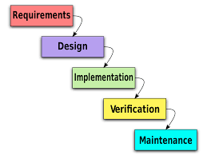

* Reason the waterfall model in the software development cycle:

→ Since we have well known, clean and fixed requirements therefore it best suits for our software development.

→ Our product definitions are stable.

→ Technology is clearly understood.

→ The project is short.

* Advantages of the waterfall model:

→ This model is simple and easy to understand and use. In, this model phases are processed and completed one at time and phases do not overlap.

→ Waterfall model works well for smaller projects where sequence is very well understood.

**Software Resources :**

**Frontend Design Tool:** Microsoft Visual Studio 2010

**Backend Design Tool:** Microsoft SQL server

**Code-Behind Language:** html, css, bootstrap

* **Functionality:**
  + 1. **Admin Login/Logout**
    2. **Add ,update, delete donor**
    3. **Add ,update ,delete blood request**
    4. **blood issued manage**
    5. **delete massages**

**List Of Modules:**

* **Dashboard**
* **Donor**
* **Blood Collection**
* **Blood Request**
* **Blood issued**
* **Message**

**Data Dictionary:**

**Admin Login Table:**

|  |  |  |
| --- | --- | --- |
| columns | Datatype | Constraints |
| id | Int(11) | NOT NULL |
| Admin_name | Varchar(100) | NOT NULL |
| password | Varchar(100) | NOT NULL |

**Donor Details Table:**

|  |  |  |
| --- | --- | --- |
| columns | Datatype | Constraints |
| id | Int(11) | NOT NULL |
| fullname | Varchar(30) | NOT NULL |
| address | Varchar(50) | NOT NULL |
| contact | Varchar(12) | NOT NULL |
| email | Varchar(30) | NOT NULL |
| age | Varchar(5) | NOT NULL |
| gender | Varchar(6) | NOT NULL |
| blood_type | Varchar(5) | NOT NULL |
| remark | Varchar(10) | NOT NULL |

**Donor Collection table:**

|  |  |  |
| --- | --- | --- |
| columns | Datatype | Constraints |
| donorid | Int(11) | NOT NULL |
| hospital | Varchar(30) | NOT NULL |
| bags | Varchar(50) | NOT NULL |
| date | Varchar(12) | NOT NULL |
| incharge | Varchar(30) | NOT NULL |

**Patient Request table:**

|  |  |  |
| --- | --- | --- |
| columns | Datatype | Constraints |
| Reg_id | Int(20) | NOT NULL |
| patient_name | Varchar(30) | NOT NULL |
| date_request | Varchar(30) | NOT NULL |
| blood_type | Varchar(10) | NOT NULL |
| bags | Varchar(5) | NOT NULL |
| amount | Varchar(100) | NOT NULL |
| purpose | Varchar(20) | NOT NULL |
| remark | Varchar(10) | NOT NULL |

**Blood Issued table:**

|  |  |  |
| --- | --- | --- |
| columns | Datatype | Constraints |
| id | Int(100) | NOT NULL |
| Issued_by | Varchar(100) | NOT NULL |
| Issued_to | Varchar(100) | NOT NULL |
| Date | Date | NOT NULL |
| amount | int(50) | NOT NULL |

**User Message table:**

|  |  |  |
| --- | --- | --- |
| columns | Datatype | Constraints |
| id | Int(100) | NOT NULL |
| name | Varchar(100) | NOT NULL |
| contact | Varchar(10) | NOT NULL |
| email | Varchar(5) | NOT NULL |
| message | Text | NOT NULL |

**DFD[Data Flow Diagram]:**

Data flow diagram symbol

|  |  |
| --- | --- |
| Symbol | Description |
|  | Data Flow – Data flow are pipelines through the packets of information  flow. |
|  | Process : A Process or task performed by the system. |
|  | Entity : Entity are object of the system. A source or destination data of a  system**.** |
|  | Data Store : A place where data to be stored**.** |

Admin

Database

User

User

**Use Case Diagram :**

Admin activity

Maintain Dashboard Details

Admin

Show user message

Maintain Blood Issued

Maintain Donor Details

Maintain Donor Collection

Maintain Blood Request

User activity:

User

Donation

Contact us

Process

Gallery

About us

Home

**Snapshots:**

**Admin activity:**

* Loading Screen:
* Login Screen:

→ Inthis page admin must give username & password.

→ If the password is correct, then he will be redirect to home page else he gets the prompt.

→ If the user forgot the password, then he will be able to change his password

from this page.

* Dashboard Page:

→ In this section of page admin get all options & access functionality of it.

→ To close the software user can use either close button or can press ESC key from

keyboard.

→ To Click on logo user will get back on This page.

* Donor Add & Edit Page:

→ In this section admin can add new donor & edit the donor information.

→ He also able to search donor & also can show available all student details.

* Collection Page:

In this page admin can take collection of donors.

* Blood Request page:

→ In the blood request page user can add & modify the donor details.

User activity:

Home page:

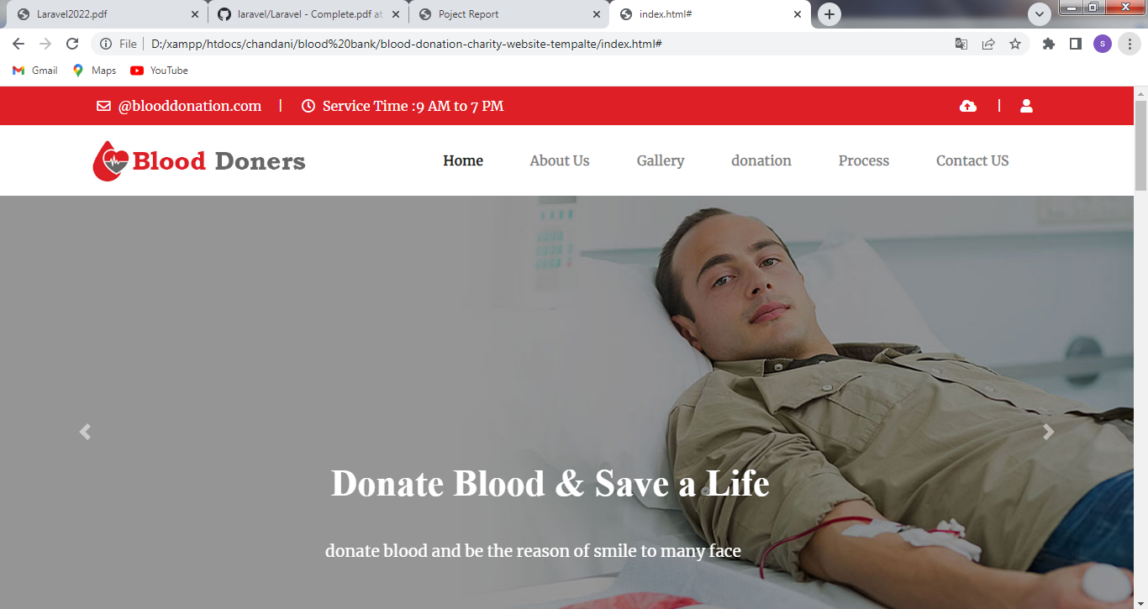

* User can show to the home page and see the website to blood donation
* User know about the blood donation website.

About Page: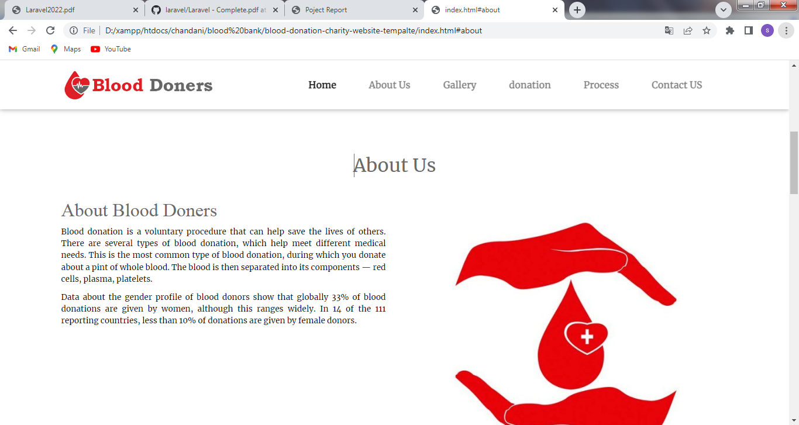

* This is the about page user know about this blood donation website

Gallery Page:

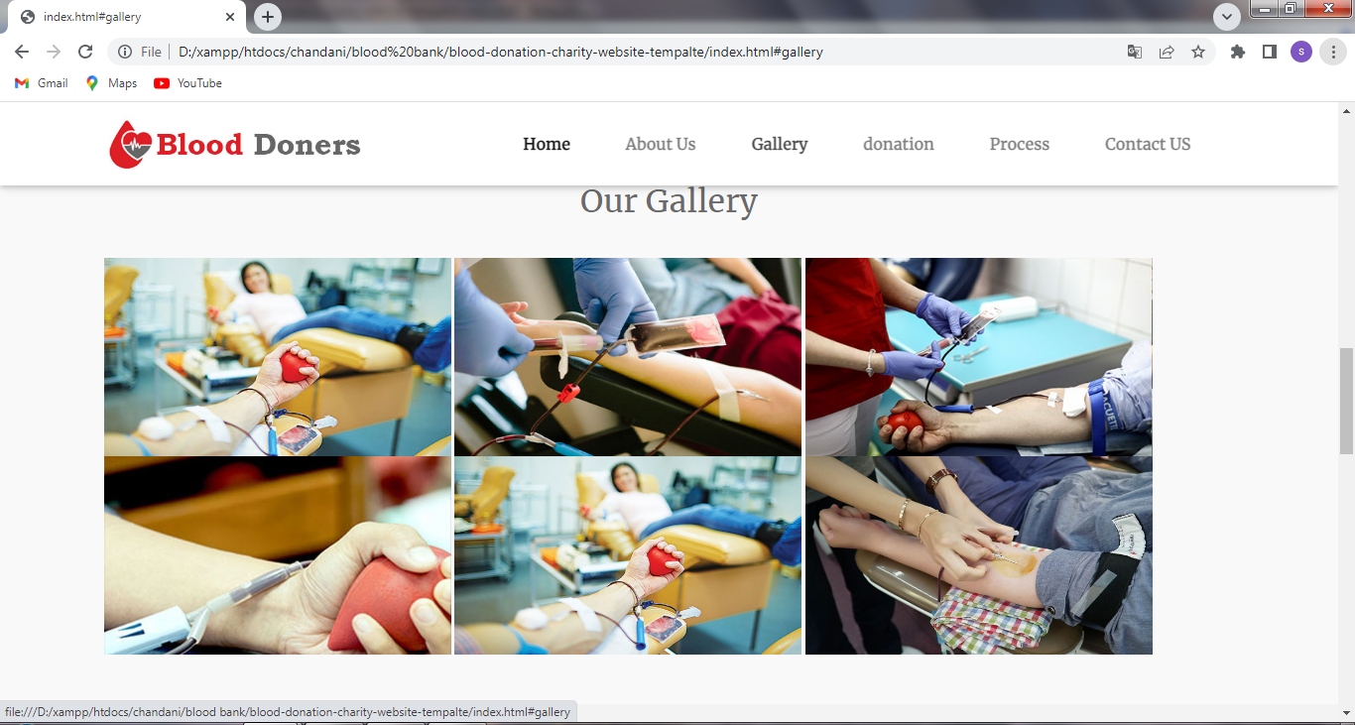

* This is gallery page user show the picture to how is work hospital.
* Future Enhancement

To conclude, Project data grid works like a component which can access all the

databases and pick-ups different function by admin. Trying to remove the many limitations and add some more functionality in future.

• Login module would be implemented with all features as per user

requirements.

• It would be more user-friendly software.

• We would give more advance software of CMS with more functionality.

• Will Implement the backup mechanism to take Backup of database.

**Conclusion:**

The project entitled as College Management System is the system that deals with the

issues related to a particular institution.

• This project is successfully implemented with all the features mentioned in

system requirements specification.

• The application provides appropriate information to users according to the

chosen service.

• The project is designed keeping in view the day-to-day problems faced by a hospital.

Deployment of our application will certainly help the hospital to reduce

unnecessary wastage of time in personally going to each department for some

information.

Awareness and right information about any hospital is essential for both the

development of student as well as faculty. So, this serves the right purpose